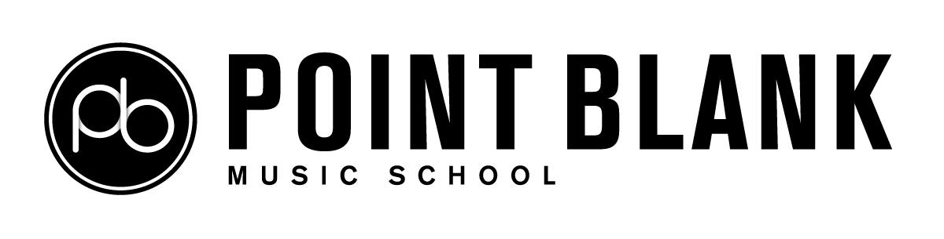

Harassment and Sexual Misconduct
Recording Form
Policy Title | Harassment and Sexual Misconduct Recording Form
Relates to | HE | X | FE |  | Online |  | X | School |  | X
Approved by | Quality and Standards Committee
Owner | Head of Quality
Date Approved | October 2019
Last Reviewed | May 2022 |  |  |  |  | Next review due: August 2023
Version | 2.1
Publication | Staff Access |  |  |  |  |  |  |  | X
 | Student Access |  |  |  |  |  |  |  | X
 | Public Access via Point Blank website |  |  |  |  |  |  |  | x

Appendix 1

Harassment and Sexual Misconduct Recording Form

Supporting guidance

Please read this supporting guidance fully before completing the Harassment and Sexual Misconduct Recording Form. If you have any questions or would like further support with completing the form, please contact the General Manager at Point Blank Music School anwar@pointblankmuscischool.com

When to use this form
  - This form should be used to make a Formal Report of harassment and/or sexual misconduct to Point Blank Music School, for the purposes of initiating the procedures within the Harassment and Sexual Misconduct Policy. This form should also be used to request that the School take action in response to an incident of harassment and/or sexual misconduct, where the Responding Party is a member of the School community, e.g. a student or staff member.

Who should complete this form?
  - This Harassment and Sexual Misconduct Recording Form can be completed by any of the following individuals:

    - A member of staff who has received a Disclosure of harassment and/or sexual misconduct from a student
    - An individual who was the subject of harassment and/or sexual misconduct and wishes to formally report this to the School to initiate an investigation

How to complete this form
  - Individuals should complete this form to the best of their knowledge. Some sections may be left blank as preferred. After submitting this form, if the Reporting Party chooses to continue with the formal process an investigation into the allegations will be conducted. This form will be used to present the Reporting Party’s experience to the investigators; however, they will also have the opportunity to speak to the investigators in person. This form will also be shared with the Responding Party in order to inform him/her/them of the allegations.

  - It should be noted that where the Reporting Party does not wish to be identified on the form, the School will be unable to take action in response to the information provided. A formal investigation can only be initiated if the Reporting Party is willing for the Responding Party to be informed of the allegation against them, which includes details of the Reporting Party. Anonymous reports can be submitted via the Anonymous Reporting Form.

Section 1. Staff receiving a of Harassment and/or Sexual Misconduct
  - This section of the form should only be completed by Point Blank Music School staff members who have received a of harassment and/or sexual misconduct. Staff members should complete sections 1, 2, 3 and 4 of the form with as much detail as possible. It is important to note that the Reporting Party will still be required to complete a Harassment and Sexual Misconduct Recording Form, should they wish to formally report the alleged incident to Point Blank Music School.
Section 2. Reporting Party details
  - The Reporting Party is the individual who was the subject of the harassment and/or sexual misconduct and has chosen to formally report this to the School. After the form is submitted, the following information will be redacted so that the Responding Party does not receive contact details for the Reporting Party: address, contact number, email address and programme of study.

Section 3. Responding Party details

  - The Responding Party is the individual who is alleged by the Reporting Party to have committed the harassment and/or sexual misconduct. If there is more than one Responding Party related to the same incident, this should be noted in the Incident Information section.

Section 4. Incident Information

  - This section should be used to describe what happened during the incident. The more detail provided in this section; the fewer questions the investigators may need to ask the Reporting Party during the investigation stages. If there is more than one incident related to the same Responding Party, please indicate this in the description of the incident. If there were witnesses who have knowledge of the incident(s), the Responding Party may wish to include them in the investigations.
Section 5. Supporting Documentation
  - Supporting documentation may include, but is not limited to photos, videos, e-mails, text messages and/or screenshots of online material. Submitted documentation will be shared with the Responding Party at the time of them being informed of the allegation and receiving details of the report.

Section 6. Outcome

  - This section should be used to describe the actions desired as a result of this disclosure. This may include requests for information on specialist support, a disciplinary response, and/or no contact arrangements/orders.

Submitting this form
  - Please submit the completed disclosure form to the General Manager at Point Blank Music School: anwar@pointblankmusicschool.com. Please refer to the Harassment and Sexual Misconduct Policy and guidance flowchart for full details of the process that follows submission of a disclosure.

Harassment and Sexual Misconduct Recording Form

Section 1. Staff receiving a of Harassment and/or Sexual Misconduct
Are you a member of staff at Point Blank who has received a of Harassment and/or Sexual Misconduct from a student?

Yes ☐ No ☐

- If yes, please complete sections 1, 2, 3 and 4 with any details provided to you during the.
- If no, please proceed to section 2 and complete all remaining sections to the best of your ability.

First name: |  | Surname:
Job title: |  | Department:
Date was received:
Was the student informed of the Reporting options and support available? Yes ☐ No ☐

Does the student intend to formally Report this incident to Point Blank Music School in order to initiate an investigation?

Yes ☐ No ☐ Unsure ☐

Has the alleged incident been reported to the Police? Yes ☐ No ☐ Unsure ☐
Section 2. Reporting Party
First name: |  | Surname:
Address:
Contact number:
Email address:
Affiliation with Point Blank Music School:
Programme of Study: (if applicable)
Section 3. Responding Party
First name: |  | Surname:
Relationship to Reporting Party: | (e.g. friend, peer, partner, stranger, etc)
Affiliation with Point Blank Music School:
Programme of study: (if applicable)
Section 4. Incident Information
Date and time of incident:
Please provide a description of the incident: | (include additional pages if necessary)
Are there any witnesses to the incident | Yes ☐ No ☐ | Have witnesses given their consent to be contacted in relation to the incident? | Yes ☐ No ☐  (If yes, please provide details of the witnesses below)
Names and contacts details of all witnesses | (Continue on an additional sheet if required)
Has anyone been informed of this incident? | Yes ☐ No ☐  (if yes, who):
Have you notified the police of this incident? | Yes ☐ No ☐  I would like more information on this option.
Section 5. Supporting documentation
Are you submitting supporting documentation? | Yes ☐ No ☐  If yes, please provide a description of the documentation you are providing.
Section 6. Outcome
What actions do you desire from this process?

Print name:

Signature: Date:

Please forward this completed form to the General Manager of Point Blank Music School. Please ensure that any supporting documentation is submitted with this form.
By email:  anwar@pointblankmusicschool.com | By mail:  Anwar Hamad  Point Blank  23-28 Penn Street, Hoxton, London, N1 5DL | In person:  You may submit this form in person to a member of staff at the Point Blank offices in Penn Street. Please ensure that the completed form is submitted in an envelope marked private and confidential, for the attention of Anwar Hamad.

For more information regarding support, reporting options, and for full details of the processes involved please refer to the Harassment and Sexual Misconduct Policy guidance flowchart.

